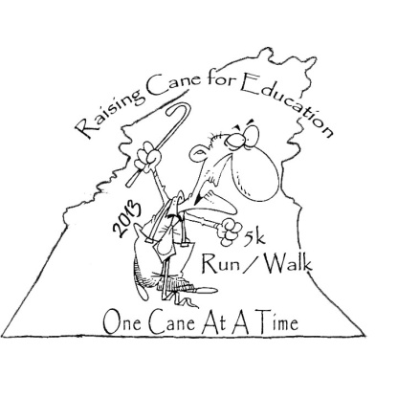
CANES FOR A CAUSE
5K RUN/WALK

Hosted by: McCreary Central High
Saturday, April 13, 2013
Whitley City First Baptist Church • McCreary County, KY Located at stoplight intersection in Whitley City on Hwy 27
Proceeds benefit the Junior Class

•Course will be all roads and ran through downtown Whitley City. The course is primarily flat with three small hills.
•Awards will be handcrafted Hiking/Walking canes made by a local artisan.
•Many door prizes will be awarded!
•Refreshments will be available.
Event Details
•5K Run/Walk to begin at 9:00 am EST

•Race-day registration to begin at 8:00 am

•$12 pre-registration fee – must be received by April 10th as pre-registered.

•$15 registration fee on race day

Awards
•Overall male and female race winner

•Top 3 male and female finishers in each of the following age groups:

14 and under, 15-19, 20-29, 30-39, 40-49, 50-59, and 60+

Questions/Information
•Contact Lucian Musgrove at (606)310-1769 or email Lucian.Musgrove@McCreary.kyschools.us

5K Canes for a Cause
Registration Form
(Please Print Clearly)

Name: _______________________ Age: _______ Gender: € M € F
Address: __________________________________________________
City: ______________________ State: _______ Zip: _______________
Phone: ______________ Emergency Contact: ____________________
Email: ____________________________________________________
Shirt Size: € S € M € L € XL € XXL
First time participating in an organized run/walk? € Yes € No
Amount Enclosed (check one)
Pre-Registration (must be received by Wednesday, April 10th) $12.00 €
Race day Registration $15.00 €

Make Checks Payable to: McCreary Central High School
Send form and payment to: 400 Raider Way, Stearns KY 42647

WAIVER
PLEASE READ CAREFUULY: Release and indemnity agreement-Running and/or walking a distance race is potentially hazardous activity. I should not enter or participate unless I am medically and physically able, and properly trained. In consideration of entering the 5k Run/Walk, and intending to be legally bound, I do release and waive for myself and for my heirs, executors, and administrators (and for my child as its legal guardian) and claims for damages and liabilities of any kind arising out of my participation in the event against all persons, entities, and agencies involved with promoting and running the event, including McCreary Central High School and all Sponsors. I hereby release all publication rights of any photographs or video taken at this event to McCreary Central High School for print and Website publication and/or advertising and social media. By signing below, I indicate that I agree to abide by this agreement and acknowledge that I ASSUME ALL RISK ASSOCIATED WITH PARTICIPATING IN THIS EVENT.

_____________________________________ Date: ____________________
Participant(s) Signature (Or parents signature if under 18)

